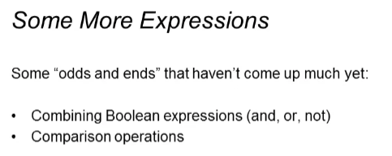

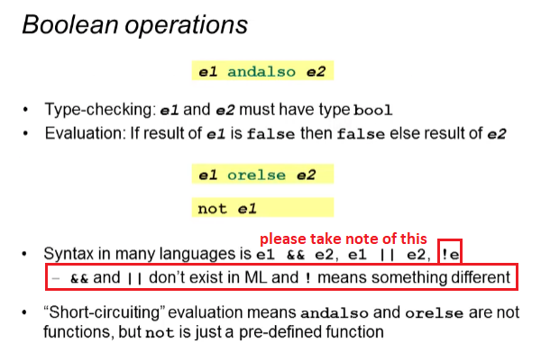

Example of short-circuiting:

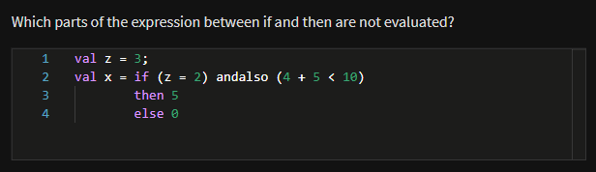

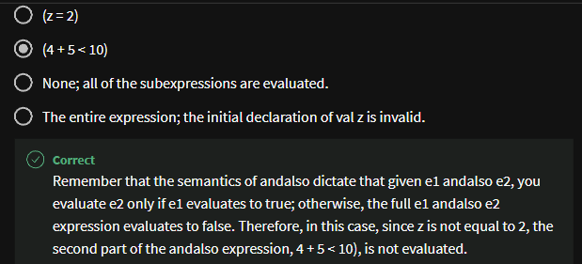

Examples of andalso and not

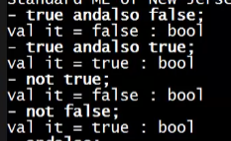

When you type in andalso;



It waits for more input! You have to put an expression on the right and left!

But when you type in not;



* It’s a function! While andalso is just like a keyword
* This is also one reason why ! in most programming language is different from not

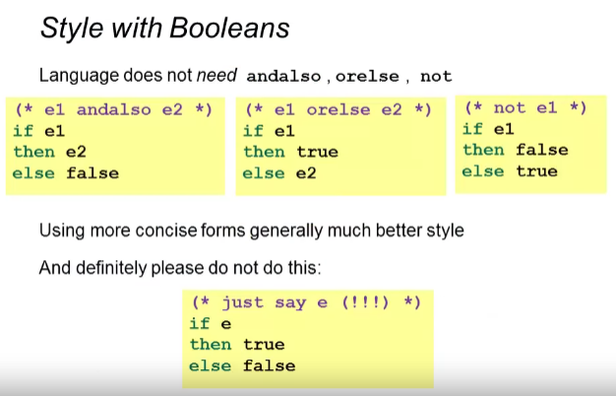

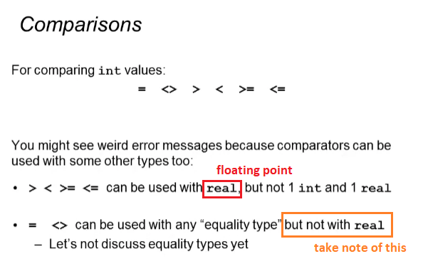

Reason behind = <> not being used with real

* Prone to rounding-off errors
* Reals should only be compared if they are within the range of some small epsilons of each other

Using > < >= <= in real and int

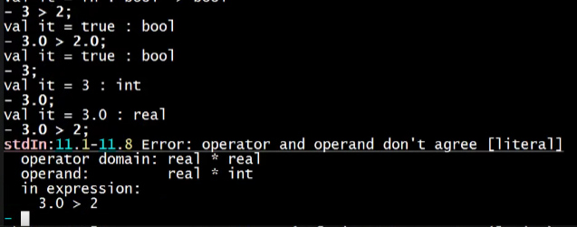

Notice we cannot use them when one is real and the other is int. it should have the same types

We can convert real to int:

